Ideation Phase

Brainstorm&Idea Prioritization Template

|  |  |
| --- | --- |
| Date | 19SEP2022 |
| Team ID | PNT2022TMID52128 |
| Project Name | A Gesture based Tool for sterile Browsing of Radiology Image |
| Maximum Mark | 4Marks |

Brain Storming 1

STEP-1 Team Gathering collaboration and select the problem statement

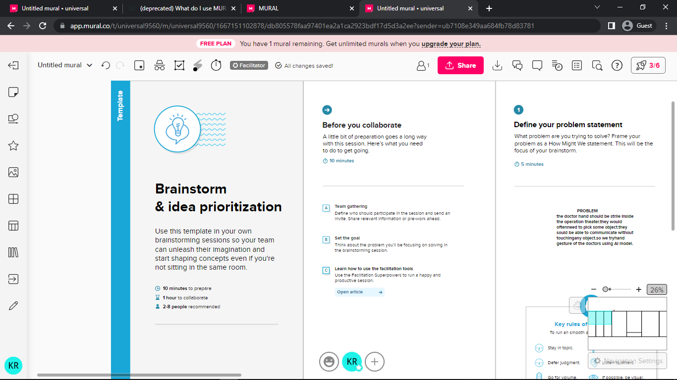

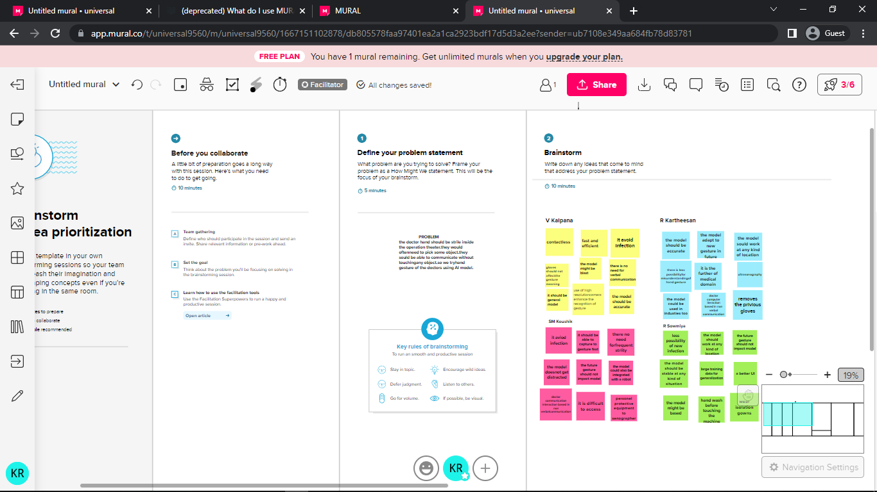

STEP-2 Brain storm,idea Listening and Grouping

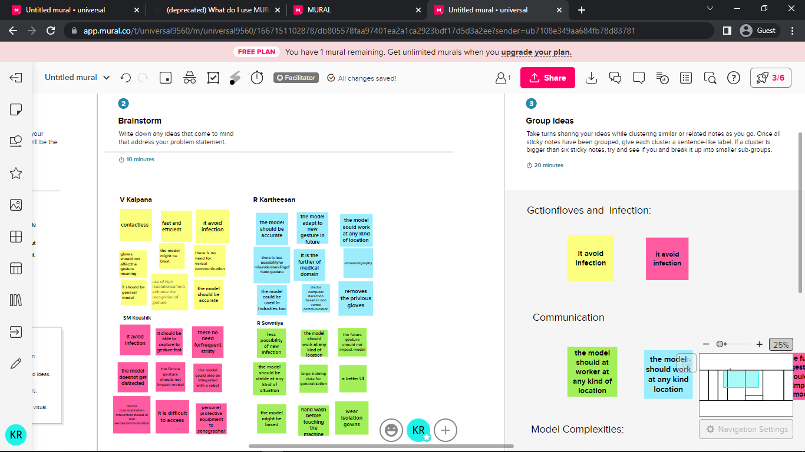

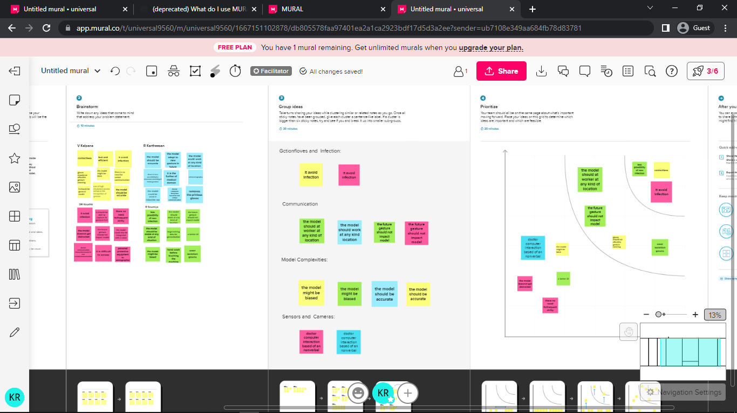

STEP-3 Prioritization

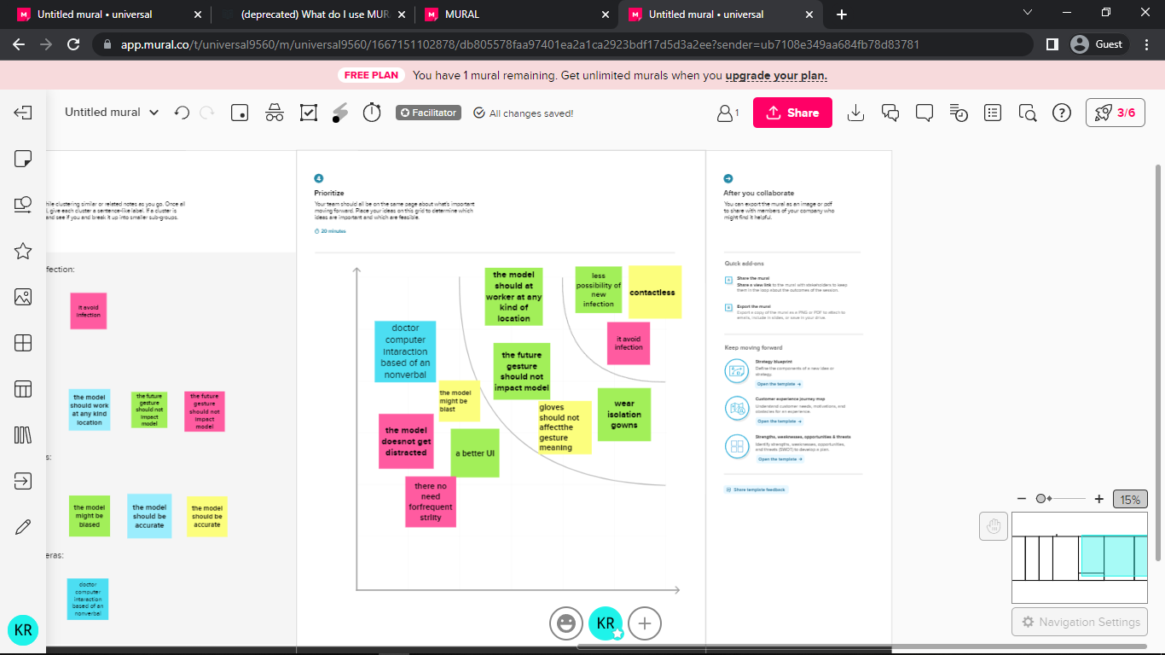

Brain Storming 2

STEP-1 Team Gathering collaboration and select the problem statement

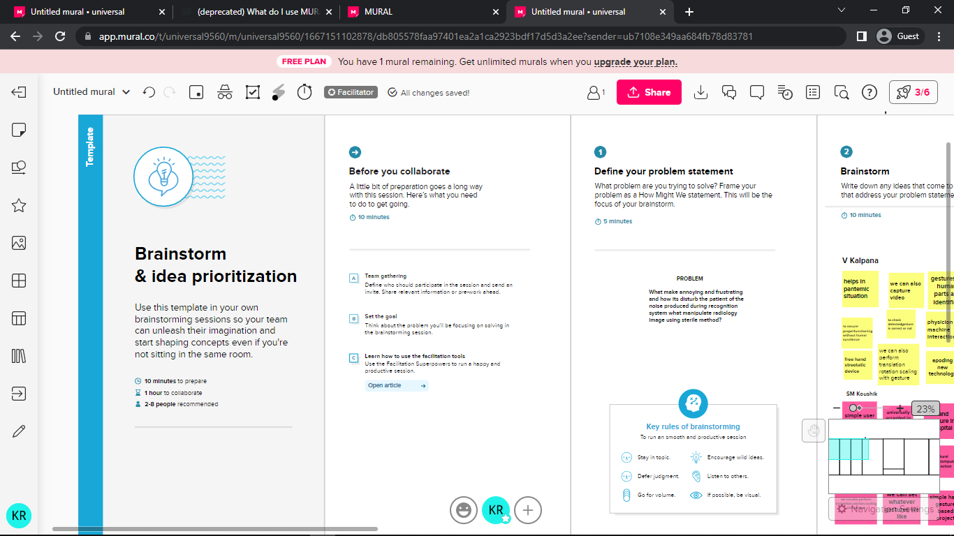

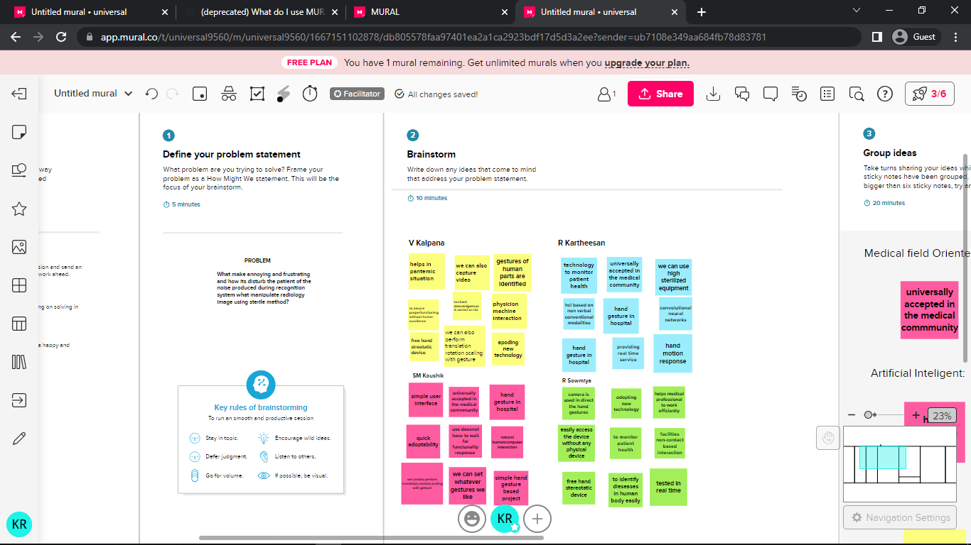

STEP-2 Brain storm,idea Listening and Grouping

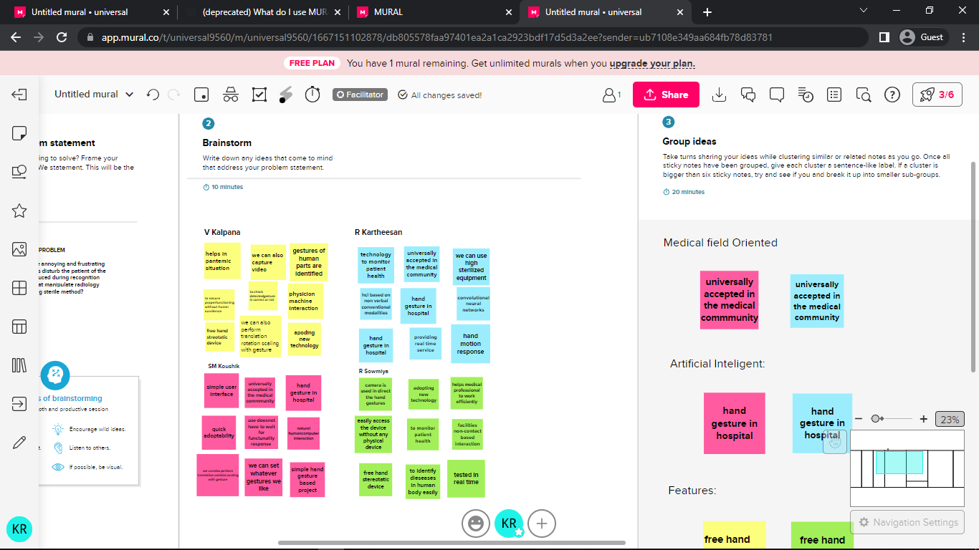

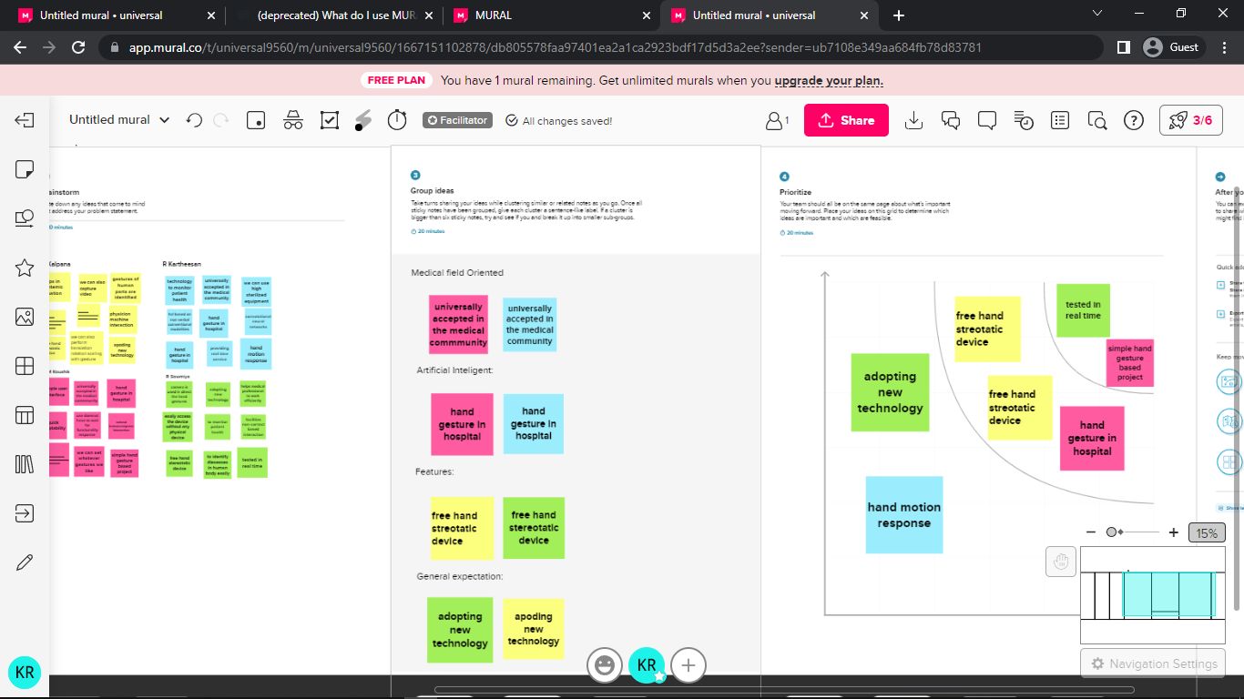

STEP-3 Prioritization

